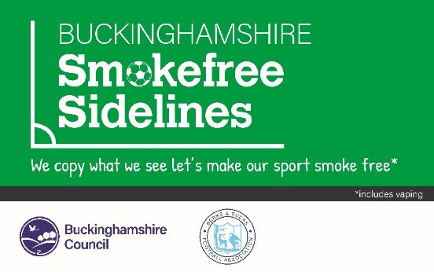

**Frequently Asked Questions**

1. **What does being a ‘Smokefree Sidelines’ Club mean?**

Working collectively and individually to actively promote Smokefree Sidelines and provide healthy, safe places that give everyone a chance to perform to their best in their chosen sport or activity. Being a Smokefree Sidelines Club supports your Club’s desire to create a healthy, family-friendly environment. Smokefree Sidelines is about giving every young person the chance to grow up in a smoke/vape free environment, so that when they are adults, they can make an informed choice about whether to smoke/vape or not.

This means that smoking/vaping is not allowed on the sidelines or anywhere in view of children, which includes:

* anywhere inside (as per [smoke free regulations](https://www.legislation.gov.uk/uksi/2006/3368/contents/made))
* anywhere on the playing fields, including the sidelines of the pitches
* near exits, entrances, windows, or doorways of any buildings
* in cars parked on site ([where children are inside](https://www.gov.uk/government/news/smoking-in-vehicles))

1. **We play in a public park so how can our Club enforce this?**

We are asking all those at games not to smoke/vape on the sidelines. If someone wants to smoke/vape, we ask them to move to a position where they and the cigarette/vape smoke cannot be seen from the pitch.

1. **Our Club doesn’t have a problem with smoking on the sidelines, why should we sign up?**

There are some parts of the county where smoking is more likely, so visiting teams may be more likely to smoke/vape on the sidelines. It’s important to support those Clubs where smoking on the sidelines is an issue, by showing a shared commitment to the campaign.

We are asking you to publicise the expectation that smoking/vaping on the sideline is not acceptable. You can choose to do this by notifying parents of the new expectation through newsletters, letters, social media, use of the publicity materials or any other mediums you and your Club considers appropriate. If there are people who do feel comfortable approaching someone, they can politely remind people of your policy.

It is important to remember children copy what adults do. Smoking/vaping in sight of children and young people can lead them to believe that it is normal, acceptable, or OK to smoke/vape.

* It is estimated that in the UK, around 207,000 children aged 11–15 years start smoking every year
* In Buckinghamshire, 5.1% of young people under the age of 17 years smoke regularly. Two thirds of smokers started smoking as children when they were most vulnerable to the addictive properties of nicotine, before realising how hard it is to quit
* Children growing up in smoking households are three times more likely to become smokers themselves.

We’re asking all adults to give every child in Buckinghamshire an equal opportunity of not smoking by de-normalising smoking and vaping in places where they play.

1. **What should we do if people refuse to stop smoking/vaping on the sidelines?**

You are not expected to personally challenge people who smoke/vape on the sidelines. Alternatively, consider whether you have explored all the options for promoting this policy: ask other Clubs what they found worked well; highlight the consequences of not having smokefree sidelines to the Club if people/supporters fail to comply with the policy; report the ongoing problem to the League and outline the steps you have taken to try and address the matter.

1. **What action can the League take if it receives complaints that people are smoking/vaping on the sidelines at games?**

We encourage Clubs to adopt this Smokefree Sidelines policy. However, we must advise you that some Leagues do not have active enforcement rules against those in breach of the policy.

Once a Club has pledged to have Smokefree Sidelines, any reports of breaches received by the respective League will be brought to the Club’s attention and they will be asked to try and correct this behaviour.

The League will work with the Club and, where appropriate, involve Buckinghamshire Council Public Health and their county FA to offer support to the Club.

1. **Why is vaping included in the policy?**

Vaping is 95% less harmful than smoking and does help people quit smoking. However, under the scheme we ask that vaping is also not permitted on the sidelines. Not vaping in the presence of young people helps guard against youth uptake of vaping.

1. **Does this apply to match officials as well?**

Yes, we want 100% of those at games not to smoke/vape within the vicinity of the pitch or the players.

1. **How will I receive my promotional resources?**

When signing up to the policy, you will be asked to enter the contact details of someone who can co-ordinate the delivery of promotional materials to you. For any further questions on this, please contact [Nphadmin@buckinghamshire.gov.uk](mailto:Nphadmin@buckinghamshire.gov.uk).

1. **What sort of publicity should we do as a Club?**

We are encouraging Clubs to do the following:

* use social media #Buckssmokefreesidelines and encourage others to share the messages
* use photographs (with appropriate permissions) with the free resources e.g selfie board
* send letters/e-mails to Club members informing them of the scheme
* add the Smokefree Sidelines logo to your paperwork and any website
* include an article in any newsletters you might have.

1. **Do we need our Club committee to agree to sign up?**

Yes, you should ensure that the whole Club has agreed to sign up at committee level. Doing this makes sure that all coaches, volunteers, and members are fully supportive and will implement the campaign effectively.

1. **Where can I direct someone would like support to quit smoking?**

If someone is thinking of quitting, they are three times more likely to succeed if they can get free local support.

There is a wide range of free support available; the most effective way is to use the free local stop smoking service called Be Healthy Bucks: [Home - Be Healthy Bucks (maximusuk.co.uk)](https://bhb.maximusuk.co.uk/). You can call 03332 300177, email [behealthybucks@maximusuk.co.uk](mailto:behealthybucks@maximusuk.co.uk) or text SMOKE to 60777 and a member of the team will be in touch within 48 hours to discuss supporting you with stopping smoking. Advisors will help you to choose the right nicotine replacement therapy for you and give you tips and advice on how to beat cravings and keep on track to becoming fully smoke free**.**

Giving up smoking is the single most important thing that people can do for their own health and for the health of those around them. Besides giving children smokefree environments, it can also create a supportive environment for all our members and supporters who wish to quit.

1. **Our Club is not based in the county of Buckinghamshire - how do we sign up?**

For Clubs that fall into Berkshire, please contact [Graham.Fisher@Berks-BucksFA.com](mailto:Graham.Fisher@Berks-BucksFA.com).