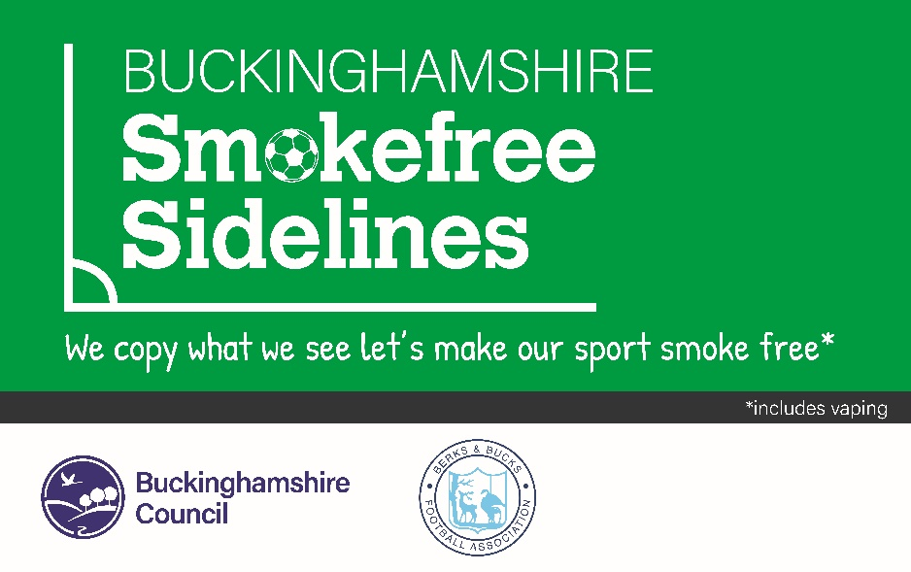

**Buckinghamshire Smokefree Sidelines**

**An invitation to sign up to our new Smokefree Sidelines initiative in Buckinghamshire.**

Smokefree Sidelines is a new exciting collaboration between the Berks and Bucks Football Association and Buckinghamshire Council’s Public Health team. This initiative is well established in several areas already including Oxfordshire, Norfolk, Hull, and Lancashire.

As the Football Association, we aim to introduce a culture of Smokefree Sidelines across Buckinghamshire to encourage harm reduction to those exposed to smoking/vaping. Children and young people are at risk the more they are exposed to smoke and the acceptance of smoking/vaping in our society. Furthermore, young people are most at risk of becoming smokers themselves if they grow up in communities where smoking/vaping is the norm. One approach to tackle this is to make places where children and young people regularly visit smoke/vape free.

Smoking remains the biggest cause of preventable deaths in Buckinghamshire,and we know that smoking/vaping often starts as a childhood addiction.

The move for Clubs to adopt a Smokefree Sidelines Policy complements existing Club policies and supports your Club’s desire to create a healthy family-friendly environment. We believe that such an environment and image will be valuable in attracting new members and positively promoting the Club within your local community.

**Together we aim to:**

* Work collectively and individually to actively promote Smokefree Sidelines to provide healthy, safe places that give everyone a chance to perform at their best in their chosen sport or activity
* Educate members of your Club, including children and young people, about the dangers of smoking/vaping and the short and long-term health consequences of smoking/vaping
* Support smokers to know where they can access help to quit smoking.

By signing up to our Smokefree Sidelines Policy **you will receive the following for free:**

* A pre-written policy for your Club to adopt
* Promotional material to use in correspondence and marketing materials
* Smokefree Sidelines resources for games and training days in and around the Club setting.

**There is no cost to the Club.**

Adopting Smokefree Sidelines is **not** about targeting smokers/vapers unfairly, but more about asking current smokers to be aware of their visibility to children who may see them smoking/vaping. The idea is to encourage smokers/vapers to either refrain from smoking/vaping during the match or to move away from the sidelines and smoke/vape where children and young adults are not present. As a sports Club involved in creating positive environments for wellbeing, we want to support our members and supporters who consider quitting. This is done through ongoing promotion and development as active role models for the children and young people involved in our Club.

**How to sign up?**

* Sign the policy form on page 4
* Complete the campaign materials form on page 5
* Please complete and return to Nicola Coote at:

**Nicola.Coote@buckinghamshire.gov.uk**

For more information or support to quit smoking in Buckinghamshire contact:

Be Healthy Bucks on 03332 300177 or text 'SMOKE' to 60777

Your engagement and commitment to this new initiative is much appreciated.

Yours sincerely,

**Graham Fisher**

Berks & Bucks Football Association

**Nicola Coote**

Buckinghamshire Council

**Buckinghamshire Smokefree Sidelines Policy**

**Name of Club:**

**Approved on [date]:**

**Approved by [Chairman/Board]:**

**To be reviewed on [date]:**

**Overview**

We are proud to be a Smokefree Sidelines Club. Research shows that children and young people who see adults using tobacco can make them think that it is normal, acceptable, or OK to smoke/vape.

Second-hand smoke is particularly dangerous for children and young people, as their bodies are still developing. As a sports Club, we encourage all our members and supporters to be active and healthy.

Giving up smoking is the single most important thing you can do for your own health and the health of those around you. That’s why we want to create a supportive environment for all our members and supporters who want to quit and to reduce the likelihood of our children and young people taking up smoking themselves.

**Who is affected by the Policy?**

This policy applies to all children and adults registered with the Club, administrators, officials, coaches, parents, and visitors to our Club’s designated playing area, including public parks and pitches.

## **Promotion of the Policy**

The Club agrees to promote the Club’s status as a Buckinghamshire Smokefree Sidelines Club using the following outlets, which support the positive messaging around smoking:

* Non-smoking signs
* Club handbook
* Advertising and promotional resources (e.g., brochures, newspaper ads etc)
* Club correspondence (letters, faxes, e-mails etc)
* Announcements
* Function speeches.

## **Behavioural expectations**

The Club understands that we are role models for children and young people who choose to participate in our Club activities, therefore coaches, trainers, officials, Club/match officials, volunteers, players, and spectators will refrain from smoking in the following conditions:

* Whilst on the sidelines of the pitch/park
* When they are acting in an official capacity for the Club, supervising children.

**E-Cigarettes/Vaping**

The Club’s Smokefree Sidelines policy also applies to e-cigarettes/vapes which are also prohibited from being used on the sidelines.

## **Non-Compliance Strategy**

We encourage Clubs to adopt this Smokefree Sidelines Policy.  However, we must advise you that some Leagues do not have active enforcement rules against those in breach of the policy.

Once a Club has pledged to have Smokefree Sidelines, any reports of breaches received by the respective League will be brought to the Club’s attention and they will be asked to try and correct this behaviour.

The League will work with the Club and, where appropriate, Buckinghamshire Council Public Health offer support to the Club.

**Promotional Materials**

The promotional materials required to adequately promote and display signage that shows that the sidelines are smokefree will be provided free of charge. See page 5 for more details.

**Evaluation and Feedback**

We are keen to collect feedback and ideas from Clubs on how best to improve the campaign. We encourage Clubs to send their feedback to [Nicola.Coote@buckinghamshire.gov.uk](mailto:Nicola.Coote@buckinghamshire.gov.uk)

We are also keen to measure the effects of the campaign and to do this we would like to complete an evaluation at three and six months. By signing this policy, Clubs agree to support this evaluation exercise.

**Timing**

An appropriate timescale will be given to inform all members of the Club regarding the adoption of this Smokefree Sidelines Policy to ensure effective compliance to key aspects of the policy. We suggest a two-month period for confirmation and promotion.

This policy is effective as of (DD/MM/YYYY)

Approved by…………………………………………………………………………………………

Role in Club…………………………………………………… Date……………………………..

To help your Club promote and share the Smokefree Sidelines messaging, we are providing each Club that signs the policy with a standard pack of promotional materials. This will include:

**Promotional Materials**

*  Posters (A4/A2)
*  Barrier tape
*  Flyers/postcards to hand out to parents on the sidelines
*  Selfie board for pictures

**On request only:**

A-frame stand

Vinyl banners for railings/fencing (2m x 1m)

**Please confirm the following so that we can arrange delivery at a suitable date and time for you:**

Name:

Contact number:

Email:

Delivery address:

**If there is anything else you would like to help you promote this campaign, please email** [**Nicola.Coote@buckinghamshire.gov.uk**](mailto:Nicola.Coote@buckinghamshire.gov.uk)  **with suggestions and your Club’s name.**